Instance initializer block->

**Instance Initializer block** is used to initialize the instance data member. It run each time when object of the class is created.

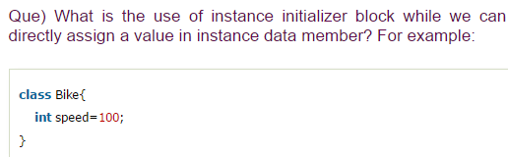



Means for entering values on array:

**Example of instance initializer block->**

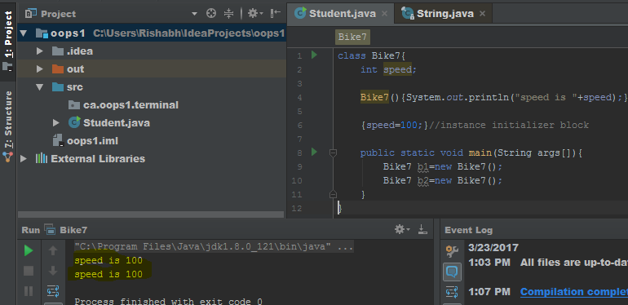

## **What is invoked first, instance initializer block or constructor?**

**->**

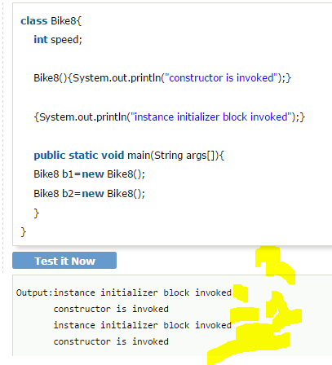

it seems that instance initializer block is firstly invoked but NO. Instance intializer block is invoked at the time of object creation. The java compiler copies the instance initializer block in the constructor after the first statement super(). **So firstly, constructor is invoked.**

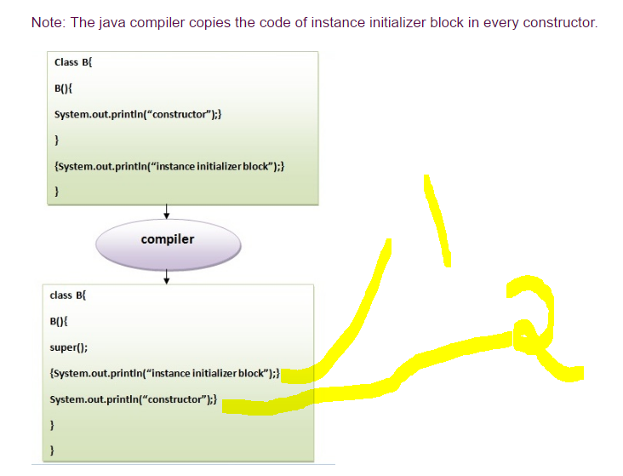

Rules for instance initializer block->

1. The instance initializer block is created when instance of the class is created.

2.The instance initializer block is invoked after the parent class constructor is invoked (i.e. after super() constructor call).

3.The instance initializer block comes in the order in which they appear.

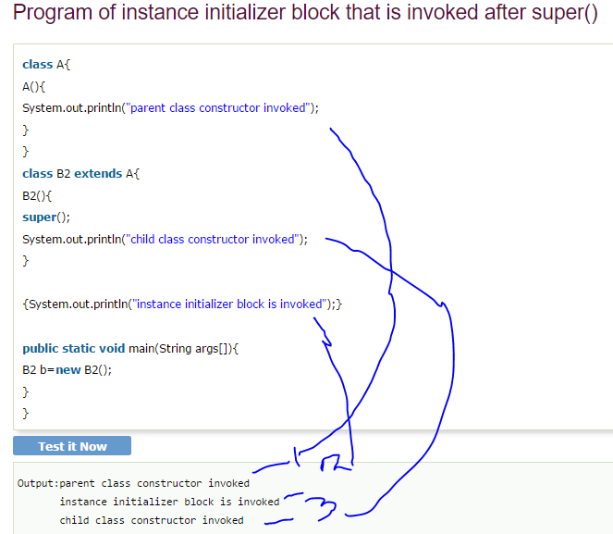

Another example->

